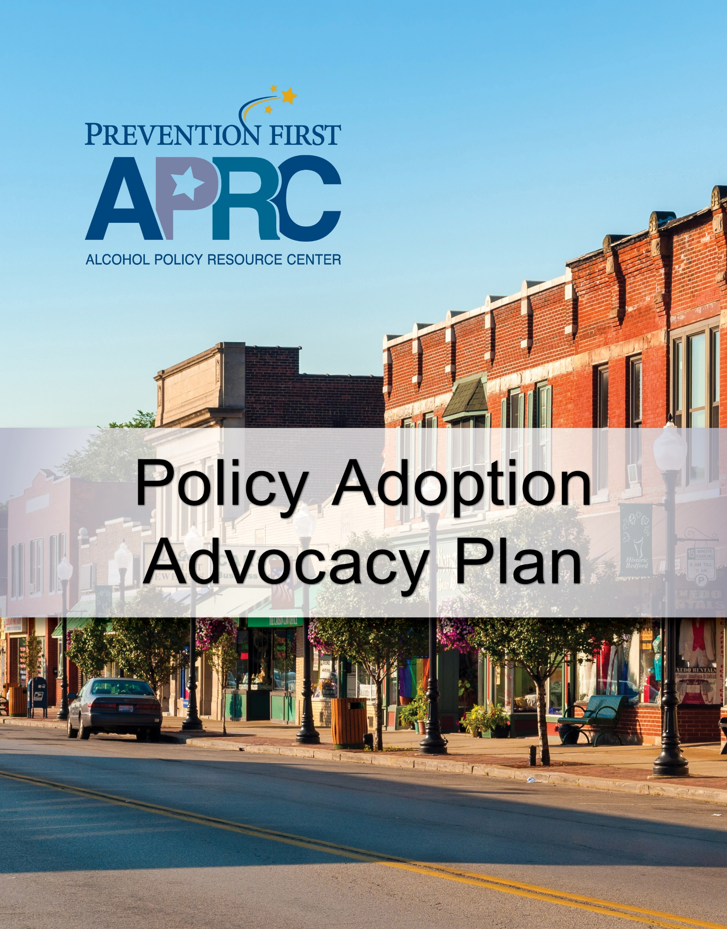



Policy Adoption Advocacy Plan

Adopting and advocating for strong alcohol policies can improve a community’s alcohol landscape. Municipalities, local officials, and prevention coalitions have the capacity to change the alcohol environment in their communities and reduce underage drinking conditions.

This ***Policy Adoption Advocacy Plan*** is a tool to guide the community’s efforts for the adoption of a new alcohol policy or adoption of a change to an existing policy.

When developing a ***Policy Adoption Advocacy Plan,*** a good place to begin is to complete an assessment using local data. The selection and development of an alcohol policy or adoption of a change to an existing policy should be based on local data that helps identify the local problems and factors that contribute to underage drinking. Contributing factors help explain why the problem currently exists in the community. Alcohol policy efforts are most likely to impact the following contributing factors identified during an assessment using local data:

* **Easy Retail Access** – Retail access refers to the ability of youth to purchase alcohol for themselves despite laws that prohibit the sale of alcohol to minors. Youth might purchase alcohol either with the use of a false identification (ID) card or buy it from a clerk who does not check the minor’s ID. Alcohol can also be obtained when youth steal alcohol from a store.
* **Easy Social Access** - Social access refers to various non-commercial avenues by which youth might access alcohol, i.e. from a friend or acquaintance over the age of 21 who can legally buy it, taking it from a parent’s liquor supply, parties where alcohol is served or is easily accessible by youth, or getting a stranger to buy it for them (often referred to as a “shoulder tap”).
* **Low Perceived Risk** – Low perceived risk is the perception among youth that there is little or no risk of physical harm and/or legal consequences of using alcohol.
* **Permissive Social Norms** – Permissive social norms are expectations, standards, behaviors, attitudes, or values that convey the acceptance of alcohol use within the family, community, or peer domains.
* **Extensive Promotion** – Extensive promotion refers to the marketing, advertising, and promotion of alcohol products that youthare exposed to through television, radio, print, sponsorships, internet advertising, point-of-sale materials, product placement, logos, and other means to gain the attention of youth.

Once the community has drafted and developed an alcohol policy or identified a change to an existing policy, completed policy research and review, and identified the political process for getting a policy passed, it’s time to build relationships and get to know key decision-makers.

To achieve policy goals, education and advocacy is often necessary to increase public support of the efforts, influence decision-makers, and increase awareness.

Funded in whole or in part by the Illinois Department of Human Services, Division of Substance Use Prevention and Recovery through a grant from the Substance Abuse and Mental Health Services Administration.



Policy Adoption Advocacy Plan Steps

1. **Clearly define the problem to be addressed by the alcohol policy effort.**

Problem statements should specifically identify the problem behaviors and contributing factors that currently exist and need to change to improve community health and conditions.

It is important to clarify and frame the problem in terms of the effects on adolescents as well as the community. During the assessment phase the key stakeholders collect data to determine the nature of the problem and causes of the problem. Using local data key stakeholders can identify the frequency, severity, scope, and economic cost of underage drinking. Problem statements should not focus on a lack of programs or services, but frame the issue in a way that lends itself to potential alcohol policy solutions.

|  |
| --- |
| What is the problem to be addressed by our alcohol policy effort?  Click or tap here to enter text. |

1. **State the rationale for how the alcohol policy effort will address the problem.**

When describing the rationale for the policy it is important to describe the policy and how it will address a local contributing factor and therefore prevent or reduce underage drinking.

|  |
| --- |
| The rationale for how the alcohol policy effort will address the problem:  Click or tap here to enter text. |

1. **Identify the target audience(s) and decision makers.**

The direct audience responsible for adopting the alcohol policy is local government decision-makers. It is important to identify those individuals up front. If you are a part of local government it is critical to identify who else will be a part of the decision-making process when it comes to this alcohol policy initiative.

Often it is equally important to target indirect audiences. Gaining support for the alcohol policy is critical and identifying key stakeholders, supporters, opponents, community members, decision-makers, non-profit organizations, and businesses can increase support from the public as well as identifying and understanding the views of your opponents.

|  |
| --- |
| Who has been identified as part of the target audience responsible for adopting the alcohol policy?  Click or tap here to enter text.  Are there any indirect audiences we need to reach out to?  Click or tap here to enter text. |

Funded in whole or in part by the Illinois Department of Human Services, Division of Substance Use Prevention and Recovery through a grant from the Substance Abuse and Mental Health Services Administration.



Funded in whole or in part by the Illinois Department of Human Services, Division of Substance Use Prevention and Recovery through a grant from the Substance Abuse and Mental Health Services Administration.

1. **Develop and implement communication strategies to deliver relevant messages and materials about the alcohol policy initiative.**

It is important to develop a message that shows the audience why they should care, why the issue is relevant to them, and what they stand to gain or lose.

Effective messaging involves adherence to the 4 C’s of messaging:

* **Clear**. Messages should be simple and clear.
* **Compelling.** Make your messages powerful, persuasive, and compelling. Ask, “Why should the audience care about this? How can I make others care?”
* **Concise**. Use sounds bites. You need to get the point across with minimal words.
* **Constant**. Repeat and reinforce the message. Keep it consistent and keep it in front of the audience.

Increasing education and awareness can provide decision-makers and community members with information that can change public opinion, build support for the policy effort, challenge misperceptions, and counter the opposition.

Education and awareness building should be based on research, facts, survey information, and outcomes.

|  |
| --- |
| What are messages we can develop for our target audience(s):  Click or tap here to enter text. |

1. **Identify counter arguments and plan your responses.**

Opponents and counter arguments will surface. It is important to anticipate what arguments you might encounter as well as try to understand where the opposition is coming from. It is important to identify concerns and arguments against the policy and develop clear and sound responses specific to each argument.

|  |
| --- |
| What are potential counter arguments we will experience?  Click or tap here to enter text.  What are clear and sound responses to the counter arguments?  Click or tap here to enter text. |



1. **Identify a spokesperson.**

It’s imperative to have a spokesperson identified and trained to speak on the issue on a moment’s notice. Having a few sound bites prepared ahead of time can ensure key points are identified and covered. The spokesperson may need to speak with a fellow decision-maker, the media, or the public and it is important to make sure the spokesperson is:

* Articulate
* Credible
* Knowledgeable
* Convincing
* Committed
* Passionate

|  |
| --- |
| Who will we designate as our spokesperson(s)?  Click or tap here to enter text. |

1. **Identify communication channels.**

The media can plan an important role in alcohol policy adoption and advocacy.

While the news media tends to be an important and popular partner in reaching different audiences, other communication channels should be used to make more personal avenues to educate decision-makers and community members on the new alcohol policy initiative.

It is also valuable to allow flexibility in your ***Policy Adoption Advocacy Plan*** so you can benefit from unanticipated media events to which you can relate your issue.

|  |
| --- |
| What communication channels will be used to reach out to our target audience(s)?  Click or tap here to enter text.  Are there key individuals who are gatekeepers of those communication channels with whom we need to build relationships?  Click or tap here to enter text. |

Funded in whole or in part by the Illinois Department of Human Services, Division of Substance Use Prevention and Recovery through a grant from the Substance Abuse and Mental Health Services Administration.



1. **Develop a *Policy Adoption Advocacy Plan* timeline.**

The timeline is the final component of the plan.

Creating a comprehensive timeline will help you get your policy initiative off on the right foot.

The timeline should capture advocacy tasks and steps to be completed, the dates the tasks and steps need to be completed by, and identify the person(s) responsible for each task and step.

When creating the timeline, keep in mind key community events that may offer opportunities for advocacy for alcohol policy efforts.

|  |
| --- |
| As we advocate for our alcohol policy efforts what will our timeline look like for accomplishing the steps listed above?  Click or tap here to enter text. |

10/2019

Funded in whole or in part by the Illinois Department of Human Services, Division of Substance Use Prevention and Recovery through a grant from the Substance Abuse and Mental Health Services Administration.