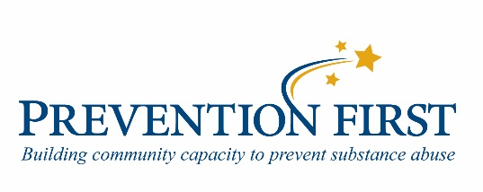
STUDENT ASSISTANCE PROGRAM
YEAR-END REPORT 2016-2017 FORM

Return report no later than June 15, 2017, to the Student Assistance Center.
Choose one of the following:
- Electronically return the Word file to dale.gasparovic@prevention.org.
- Mail report to Student Assistance Center, 1109 S 22nd
- Fax report to the SAC at 312-988-7096

Demographics

School Name _______________________________________________________________________
School District Name and Number _________________________________________County______________________
Person completing this form ___________________________ Phone #( )________________________
E-mail ______________________________
Number of years your SAP has been in place: (please check one) _____0 to 5 _____ 6 to 10 _____ 11 or more
Grades Served: (please check one) _____PreK-5 _____6-8 _____9-12 _____ Other

For any of the following questions that do not apply to your SAP services, please write N/A in the blank.

Referral Data / Student Interventions/Action Plans / Student Programs

For the 2016-2017 school year (students may be counted more than once)
- _____ How many students received Student Assistance intervention services?
- _____ How many students participated in a Student Assistance educational support group?
- _____ How many students participated in a Student Assistance sponsored program or event?
- _____ For how many students receiving SAP services did you create at least one school-based student intervention/action plan?
- _____How many students were connected to in-school services not sponsored by the SAP?

- _____ How many students receiving SAP services were connected to community services for any reason?

Student Progress

For the following questions, you may count a student more than once when a student qualifies for more than category.
- _____ How many students receiving SAP services improved during the year? (academically, behaviorally, school attendance, mental or physical health, substance use, violence, stress/anxiety, life skills, etc.)?

- How many students: _____ improved academically? _____ improved behaviorally?
_____ improved attendance at school? _____ improved a health related problem?
- _____ How many students demonstrated or reported a more positive attitude toward school?
- _____ How many students receiving SAP services maintained their status (did not get worse)? (Do not include students counted in a. through c.)
3. Parent / Community / School Collaboration

_____ What is the total number of parents who participated in a Student Assistance Program sponsored event or information program this year?

For the total number of students receiving Student Assistance intervention services,

_____ How many families / guardians were contacted by the SAP as a result of a SAP referral? (phone call, letter, home visit, meeting at school)
_____ How many families / guardians were contacted by the SAP as a result of student participation in a Student Assistance educational support group?
_____ How many families / guardians received general information such as SAP pamphlets or brochures or letters in a general information distribution such as school packets or parent nights, etc?
_____ How many families / guardians received information about community services such as resource lists or agency pamphlets?

Program Data

As a result of having Student Assistance services in your building. Please check all that apply.

- _____ At-risk students are more effectively identified
- _____More positive relationships between students and adults in the building occurred
- _____ Access to life skill development improved
- _____Staff attitudes toward helping students improved
- _____Staff sense of responsibility for all students in the building increased
- _____ Staff information about support services increased
- _____Communication improved between staff/ students/parents
- _____Student support services improved
- _____Community resource utilization has improved
- _____Parent involvement in the educational process increased
- _____Parent trust in working with the school increased
- _____Parent education about support services increased
- _____ A reduction in school related problem behaviors occurred
- _____ School climate has improved
- _____ Collaboration with administration improved regarding policies and procedures around school conduct, attendance, and other school / parent, community
- _____Evaluation data regarding program effectiveness is provided to key decision-makers in the building
- _____Evaluation data regarding program effectiveness is provided to key decision-makers in the district.

