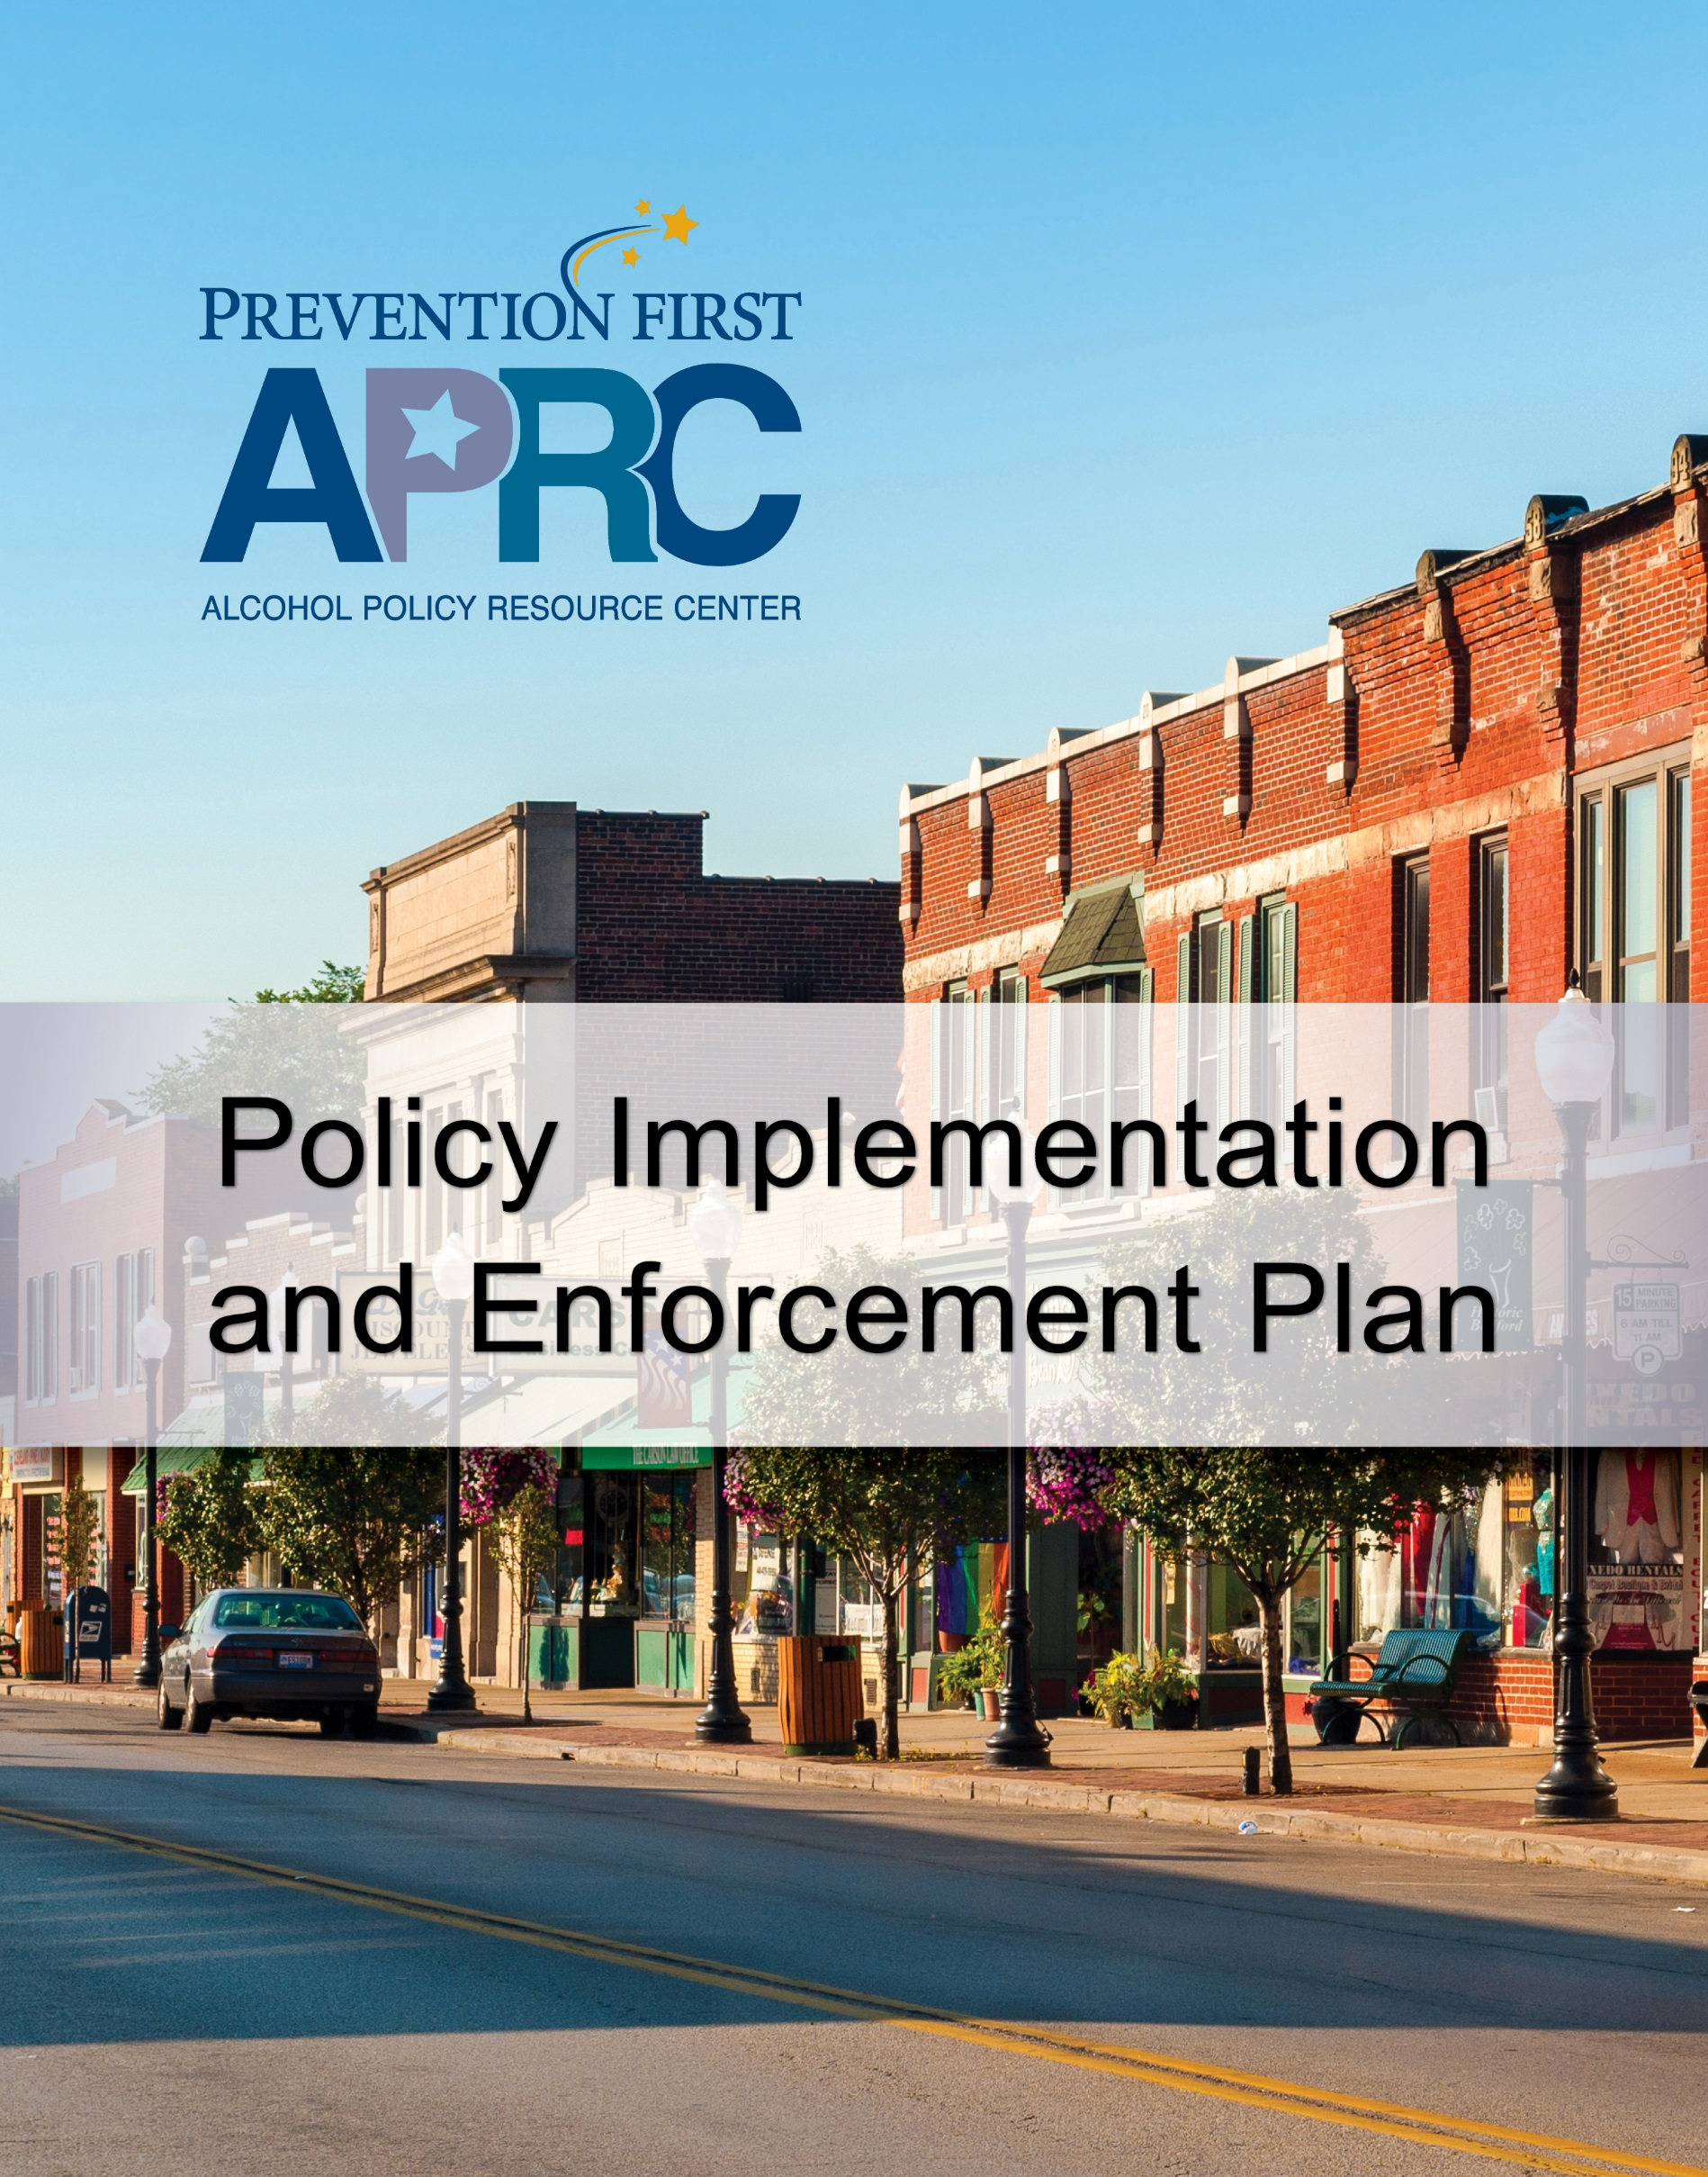



Funded in whole or in part by the Illinois Department of Human Services, Division of Substance Use Prevention and Recovery through a grant from the Substance Abuse and Mental Health Services Administration.

Policy Implementation and Enforcement Plan

The **Policy Implementation and Enforcement Plan** can help community leaders plan for the enforcement of an alcohol policy once it is passed. After the enormous amount of effort to draft or change an alcohol policy and work to get the policy passed, it is imperative to continue working to ensure the policy is implemented and effective. Work on an alcohol policy does not end once the policy is passed. An alcohol policy is only as good as the enforcement of it – if the policy is not enforced, it won’t be effective. This **Policy Implementation and Enforcement Plan** can assist community leaders and prevention coalitions to ensure the new alcohol policy has full support of law enforcement and is actively and vigorously enforced.

**Policy Implementation and Enforcement Plan**

1. **Secure support of law enforcement.**

It is critical for community leaders and prevention coalitions to develop and maintain a positive working relationship with law enforcement. If law enforcement is resistant to or apathetic about implementing the policy, determine why and work to secure their support.

* If law enforcement doesn’t see the need for prevention or the alcohol policy, make the case for prevention by bringing attention to the problems associated with underage drinking and by using data from your community that illustrates the problem. One data source that provides data at the local level and state level is the Illinois Youth Survey (IYS). The IYS is a self-report survey administered biennially to students in 8th, 10th, and 12th grades throughout Illinois and is designed to gather information about a variety of health and social indicators including substance abuse patterns and attitudes of Illinois youth.
* Community support of an alcohol policy is important. Sometimes law enforcement isn’t aware the community supports the policy and may be concerned about objections to enforcement. In this case, generate and demonstrate the support that exists for the alcohol policy effort by linking law enforcement with key supporters, provide positive feedback from community polls, and engage media advocacy to build support.
* If law enforcement doesn’t believe they have the resources to enforce the policy, look for opportunities to support some of the administrative aspects of the enforcement of the alcohol policy.

|  |
| --- |
| What strategies can we use to secure the support of law enforcement?  Click or tap here to enter text. |



Funded in whole or in part by the Illinois Department of Human Services, Division of Substance Use Prevention and Recovery through a grant from the Substance Abuse and Mental Health Services Administration.

1. **Secure support of adjudicators.**

The **Policy Implementation and Enforcement Plan** will address how judicial partners will be informed of the alcohol policy and include strategies to garner and maintain their support.

* Legal advice should be sought from the State’s Attorney or the local legal counsel regarding policy development and enforcement plans. In jurisdictions where state statutes will be applied, the guidelines should be reconciled with the county State’s Attorney. Where a local ordinance is used, the city or village corporation counsel should be consulted.
* New alcohol policies, and the enforcement of them, greatly impact law enforcement and the criminal justice system. Sharing the plan with regulators, courts, and prosecutors allows them to establish systems and prepare to deal with the additional charges generated by enforcement.

|  |
| --- |
| What strategies will we use to secure the support of adjudicators?  Click or tap here to enter text. |

1. **Develop protocols and procedures.**

Enforcement efforts must adhere to state and local requirements and take into consideration laws, policies, and ordinances.

Enforcement protocols and procedures will most likely need to be written by enforcement officials. Community leaders should work with law enforcement partners fully to ensure protocols and procedures address these issues.

|  |
| --- |
| Are there ways we can provide support to law enforcement as they create protocols and procedures for the enforcement of this alcohol policy?  Click or tap here to enter text.  How can we ensure enforcement protocols and procedures are written?  Click or tap here to enter text. |



Funded in whole or in part by the Illinois Department of Human Services, Division of Substance Use Prevention and Recovery through a grant from the Substance Abuse and Mental Health Services Administration.

1. **Identify sanctions and address when sanctions will be applied.**

Local ordinances should clearly state the fines/penalties for violations to ensure transparency and fairness. Fines should be swift, certain, and have appropriate severity. Local ordinances allow for greater flexibility to apply creative sanctions and/or progressive fines than if state law is used.

* Progressive fines are graduated for first, second, and subsequent offenses. For example, an initial violation fine might be $500, a second violation $1000, and a third and subsequent violation incur a license suspension or jail time.
* Local ordinances also allow for creative sanctions that might impose penalties other than fines and encourage voluntary compliance. For example, an alcohol policy might stipulate that an initial fine can be waived if the violator attends an educational program.
* The policy should also address when sanctions will be applied. (Sanctions should be applied for a license violation on the same day of the week as the violation occurred and accounting for conditions that are similar to when the violation occurred.)

|  |
| --- |
| What sanctions will be applied for the violation of the law/ordinance?  Click or tap here to enter text. |

1. **Share data and publicize results.**

The **Policy Implementation and Enforcement Plan** should include strategies for getting the media on board and outline the methods to be used for collecting and reporting data.

Publicizing results can foster voluntary compliance with the alcohol policy by making it clear that the laws are being enforced. Increased media attention can also help raise community awareness of the problems stemming from underage drinking, strengthen community norms, and reassure the public that violators of underage drinking laws are held accountable for their behavior.

|  |
| --- |
| What strategies can we use to publicize enforcement results?  Click or tap here to enter text.  How can we ensure enforcement results are publicized?  Click or tap here to enter text. |

10/2019